- Product and Company Identification
Product Name | Embalming Fluid
Synonyms | None
Recommended Use | Preserving Specimens
Company Identification | Bio Corporation  3910 Minnesota Street SW  Alexandria, MN 56308
Telephone | Bio Corporation 1-800-222-9094  CHEMTREC 1-800-424-9300
- Hazards Identification
GHS Classification | Eye irritation (category 2a), skin irritation (category 2), Acute toxicity (oral, dermal, inhalation) category 4, respiratory irritation (category 3), carcinogenicity (category 2)
Pictogram | 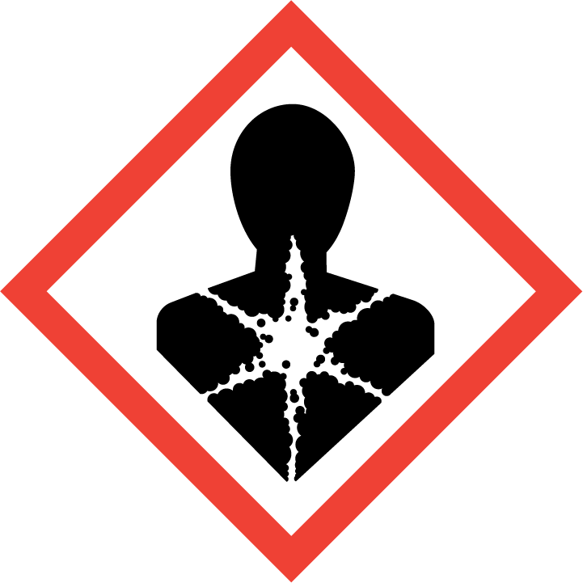
Signal Word | Danger Warning
Hazard Statement(s) | Harmful if swallowed.  Causes skin irritation.  Causes eye irritation.  May cause an allergic skin reaction.  May cause respiratory irritation.  Possible Carcinogen.
Precautionary Statement(s) | Read all safety information before use.  Wash skin thoroughly after handling.  Do not eat, drink or smoke when using this product.  Wear protective gloves/ protective clothing/ eye protection.  IF SWALLOWED: Call a POISON CONTROL CENTER  IF ON SKIN (or hair): Wash with soap and water then rinse thoroughly. If skin irritation or rash occurs get medical advice or attention.  IF INHALED: If breathing becomes difficult remove person to fresh air and keep comfortable for breathing. If concerned get medical attention.  IF IN EYES: Rinse cautiously with water for a minimum of 15 minutes. Remove contact lenses, if present and easy to do so.  If concerned get medical advice/attention.  Keep container tightly closed. Store in a cool, dry, well-ventilated place.  Dispose of contents/container in accordance with local/regional/national regulations.
- Composition/Information on Ingredients
Mixture  Ingredient Name |  |  |  | CAS Number |  |  | %
Water  Ethylene Glycol |  |  |  | N/A  107-21-1 |  |  | > 90.5  < 5.0
Phenol |  |  |  | 108-95-02 |  |  | < 2.7
Formalin |  |  |  | 50-00-0 |  |  | < 1.8
- First Aid Measures
Eye Contact | Rinse cautiously with room temperature water for at least 15 minutes. Remove contact lenses, if present and easy to do. Consult a physician if irritation persists.
Skin Contact | After contact with skin, wash with plenty of soap and water and seek medical advice if needed.
Inhalation | Move person to fresh air. Have them rest in a comfortable position and seek medical advice if needed.
Ingestion | Call Poison Control. Do NOT induce vomiting unless instructed to do so by medical personnel. Never give anything by mouth to an unconscious person. Rinse mouth with water.
- Firefighting Measures
Extinguishing Media
Suitable | Water spray, dry chemical, carbon dioxide or appropriate foam.
Not Suitable | No data available.
Fire-fighting Methods and Protection | Firefighters should wear full protective equipment and NIOSH approved self-contained breathing apparatus.
Fire & Explosion Hazards | Fire or excessive heat may produce hazardous decomposition products.
- Spill or Leak Procedures
Personal Precautions,  Protective equipment and  Emergency procedures  Environmental Precautions | Avoid direct eye and skin contact, breathing vapors maybe irritating. Use gloves and eye protection, ventilate area of the spill, wash down with water or absorb with paper towels or granulated clay, then dispose of properly.  Follow local state and federal regulations regarding releases.
- Handling and Storage
Handling | Wear protective gloves and safety glasses. Avoid direct eye and skin contact. Do not eat, drink or smoke when using this product.
Storage | Keep containers closed. Store in a cool, dry, well-ventilated place.
- Exposure Controls/Personal Protection
Ingredient Name | ACGIH TLV |  |  |  | OSHA PEL
Ethylene Glycol | 100 mg/m³ |  |  |  | 125 mg/m³
Phenol | 5 ppm |  |  |  | 5 ppm - TWA
Formalin | 0.37 mg/m³ |  |  |  | 0.75 ppm – 8-hr TWA  2 ppm STEL (15 min)
Engineering Measures | Room ventilation might be needed to insure operator comfort and to keep levels below exposure limits.
Hygiene Measures | Avoid contact with skin, eyes and clothing. Wash hands with soap and water after handling the product.
Respiratory | None should be needed if normal room conditions exist. If airborne concentrations are above the applicable exposure limits use NIOSH-approved respiratory protection.
Eyes and Face  Skin | Wear safety goggles or glasses while handling this product.  Wear gloves and protective clothing.
- Physical and Chemical Properties
Appearance |  |  | Clear, colorless liquid
Odor  Odor threshold |  |  | Medicinal, Pungent  Not Determined
pH  melting /Freezing Point (°F)  Boiling Point / Range (°F)  Flash Point  Evaporation rate (butyl acetate = 1)  Flammability  Upper / lower flammability  Vapor Pressure (mm Hg, 20 °C)  Vapor Density (air = 1)  Relative Density  Solubility  Partition coefficient  Auto ignition temperature  Decomposition temperature  Viscosit |  |  | 6.9  Not Determined  Not determined  Not Determined  Not determined  Not determined  Not determined  Not determined  Not determined  Not determined  Soluble  Not determined  Not determined  Not determined  Not determined
- Stability and Reactivity
Reactivity  Chemical stability  Hazardous Reactions  Conditions to Avoid | Not Reactive  Stable  None Known  None Known
Materials to Avoid | Strong Acids, Strong Oxidizing Agents
Decomposition Products  Hazardous Polymerization | Carbon Monoxide, Carbon Dioxide, other Hydrocarbons  Will Not Occur
- Toxicological Information
Eye |  | May cause eye irritation.
Ethylene Glycol |  | Eyes - rabbit – mild eye irritation – 24 hr
Phenol |  | Eyes – rabbit – no data available
Formalin |  | Eyes - rabbit – eye irritation – 24 hr
Dermal |  | May be harmful if absorbed through skin.
Ethylene Glycol |  | Dermal LD50 – rabbit – 10,626 mg/kg
Phenol |  | Dermal LD50 – no data available  Skin corrosion/irritation: no data available
Formalin |  | Dermal LD50 – rabbit – 270 mg/kg  Skin corrosion/irritation: no data available
Inhalation |  | May be harmful if inhaled.
Ethylene Glycol |  | Inhalation LC50 – no data available
Phenol |  | Inhalation LC50 – no data available
Formalin |  | Inhalation LD50 – rat – 590 ppm – 4 hr
Oral |  | Harmful if swallowed.
Ethylene Glycol |  | Oral LD50 – rat – 4,700 mg/kg
Phenol |  | Oral LD50 – no data available
Formalin |  | Oral LD50 – rat – 800 mg/kg
Potential Chronic Health Effects
Carcinogenicity |  | No Data Available
Mutagenicity |  | No Data Available
Teratogenicity |  | No Data Available
Fertility Effects |  | No Data Available
- Ecological Information
Eco toxicity  Biodegradability  Bioaccumulation  Mobility  Other adverse effects | Toxicity to fish:  LC50 – oncorhynchus mykiss (rainbow trout) – 18,500 mg/l – 96 hr. (Ethylene Glycol)  NOEC – pimephales promelas (fathead minnow) – 39,140 mg/l – 96 hr. (Ethylene Glycol)  LD50 - oncorhynchus mykiss (rainbow trout) – 8.9-12.3 mg/l – 96 hr. (Phenol)  LD50 – pimephales promelas (fathead minnow) – 11.5-50.9 mg/l – 96 hr. (Phenol)  LC50 – fish – > 10 mg/l – 96 hr (Formalin)  Toxicity to aquatic invertebrates:  NOEC – daphnia – 24,000 mg/l – 48 hr. (Ethylene glycol)  LC50 – daphnia magna (water flea) – > 41,000 mg/l – 48 hr. (Ethylene Glycol)  EC50 – Daphnia magna (water flea) – 10.2-15.19 mg/l - 48 hr (Phenol)  Concentration factor – 0.60 (Ethylene Glycol)  Phenol – Biodegradable  Formalin – Biodegradable  Concentration is not expected to occur.  No Data  No other adverse effects known.
- Disposal Considerations
Waste Disposal | Dispose of in accordance with all applicable Federal, State and Local Regulations.
- Transportation
The data provided in this section is for information only and may not be specific to your package size or mode of transport. You will need to apply the appropriate regulations to properly classify your shipment for transportation.
US DOT 49 CFR 172.101 | Non-bulk Shipments (Drums/Totes) |  |  |  |  | Bulk Shipments (Tank Trucks/Rail Cars)
Proper Shipping Name | Embalming Fluid |  |  |  |  | Same
Hazard Class | N/A |  |  |  |  | Same
Identification Number | N/A |  |  |  |  | Same
Packing Group | N/A |  |  |  |  | Same
Reportable Quantities | N/A |  |  |  |  | Same

- Regulatory Information
SARA Title III Section 313 | This product is known to contain the following chemicals which are listed in 40 CFR  372.65 As chemicals requiring notification. This information must be included in all  SDS’s that are copied and distributed for this product.  Ethylene Glycol – CAS# 107-21-1  Phenol – CAS# 108-95-02  Formalin – CAS# 50-00-0
TSCA – Toxic Substances Control Act | All components of this product are listed on the TSCA Inventory or are excluded from listing requirements.
RCRA – Resource Conservation and Recovery Act | The requirements of the federal hazardous waste regulations do not apply unless the waste fails to pass any of EPA’s four tests for determining hazardous wastes. Note: If this product is altered, it is the responsibility of the user to determine whether the material meets the criteria for hazardous waste at the time of disposal.
- Other Information
Revised: 5-4-2016
The information contained herein is given in good faith, but no warranty, representation, inducement, or license of any kind is made, except that the information is accurate to the best of Bio Corporation’s knowledge, or is obtained from sources believed by Bio Corporation to be reliable and accurate. Bio Corporation does not assume any legal responsibility for use or reliance upon the information being furnished. Customers are encouraged to conduct their own research before using any product and read the Safety Data Sheet.

